**EXPERIMENT 7**

**DQL COMMANDS (COLLEGE SCHEMA)**

**Aim:**

* Display student id and marks from the student table.
* Display faculty id and name from the faculty table.
* Display who got grade A.
* Display whose marks are less than 50.
* Display the female students whose marks are between 50 to 60.
* Delete the failed students.
* Display activity id and name using object.
* Display student id, faculty id using course name condition with object.
* Select department name starting from ‘c’ and faculty name ending with ‘ ’.
* Select activity having characters between ‘ck’.
* Group by faculty id and display.
* Display the students list whose grade is A using having.
* Display the faculty list who are teaching PPS.
* Apply aggregate functions in student marks - max, min, sum, count, avg.

**Components:**

1. DQL statements are used for performing queries on the data within schema objects. The purpose of the DQL Command is to get some schema relation based on the query passed to it.

Example of DQL:

* + [SELECT](https://www.geeksforgeeks.org/sql-select-clause/) – is used to retrieve data from the database.

**Code:**

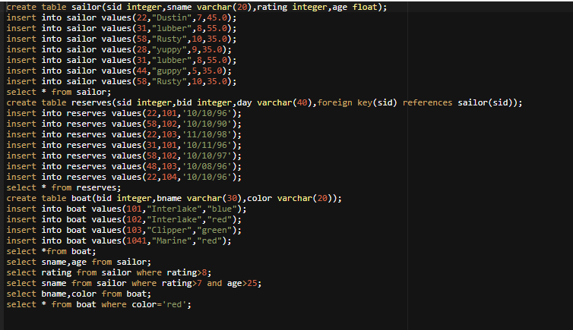

**Output:**

sid sname rating age

22 Dustin 7 45

31 lubber 8 55

58 Rusty 10 35

28 yuppy 9 35

31 lubber 8 55

44 guppy 5 35

58 Rusty 10 35

sid bid day

22 101 10/10/96

58 102 10/10/90

22 103 11/10/98

31 101 10/11/96

58 102 10/10/97

48 103 10/08/96

22 104 10/10/96

bid bname color

101 Interlake blue

102 Interlake red

103 Clipper green

1041 Marine red

sname age

Dustin 45

lubber 55

Rusty 35

yuppy 35

lubber 55

guppy 35

Rusty 35

rating

10

9

10

sname

lubber

Rusty

yuppy

lubber

Rusty

bname color

Interlake blue

Interlake red

Clipper green

Marine red

bid bname color

102 Interlake red

1041 Marine red